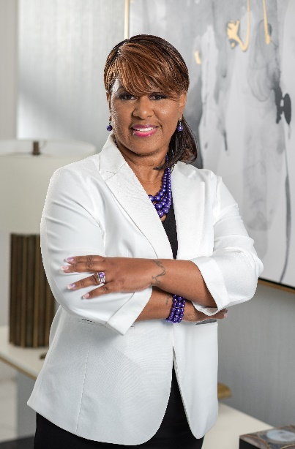
Minister Patricia A. Fowler
Minister Patricia is a native of Washington, D.C., who was called by God to preach the Gospel of Jesus Christ in July of 2013, under the leadership and tutelage of Apostle Lillian Grier and Dr. Loretta Rich, Ph.D. of Grace and Mercy Ministries Bible College and Seminary School of Evangelism. Minister Fowler was licensed and Ordained to the Office of the Evangelist/Teacher on December 6, 2014, where she received an associate degree in Biblical Studies. She became a Board-Certified Christian Counselor in 2021. She is a Certified Victims Services Advocate with ACTS Shelter of Prince William County. She is currently a Licensed and Ordained Minister currently service as a Leader at LifeConnect VA Community Church located in Woodbridge, Virginia under the leadership of Pastors Stephen and Nicole Brown, where our focus is on connecting others to God, Family and the Community.

She recently graduated from the Roper Academy at the University of Baltimore, Criminal Justice Division as a Maryland Victim Services Certified Professional (MVACP). She uses her past experience as a married woman in an ungodly and abusive relationship to help guide and mentor other young men and women to be led to love the correct way through her Pure Heart Ministries, LLC. She is a 25-year survivor of Domestic Violence. Minister Patricia felt it was her obligation to give back by helping others. In June 2023 she formed Pure Hearts Restored, Inc. 501C3, where she teaches workshops, classes, training, advocates for victims and provides resources and connections to other Organizations. She is a six (6) time author with 2 of her books specifically directed towards domestic violence. Minister Patricia continues to take training courses and attend seminars to help further her education to be able to help others accurately. She also is a mentor for women in Jessup prison.

Her favorite scripture is found in Matthew 7:7, “Seek and ye shall find, knock and it shall be opened, ask ye shall receive” (KJV). Favorite saying “it is what it is”. She is the mother of 4 beautiful adult children and 5 granddaughters and 3 grandsons.

For bookings & speaking engagements, please contact her at one of the following methods: pureheartsrestored@gmail.com, or 540-359-2434.

